BansilalRamnathAgarwal Charitable Trust’s

Vishwakarma Institute of Information Technology

*(Department of Electronics & Telecommunication)*

**

*A*

*Project entitled*

*“Smart Wireless controlled Pick-N-Place Line Following Robot****”***

*Submitted by*

Arpit Shrivastava (T150393199)

Durgesh Vitore (T150393219)

Tejas Shinde (T150393196)

Employability Skills and Mini Project

T.E. Electronics & Tele-Communication

*of*

*University of Pune*

*Under the supervision of*

**(Dr.S.R.Joshi)**

*Year 2018 – 2019*

BansilalRamnathAgarwal Charitable Trust’s

Vishwakarma Institute of Information Technology

*(Department of Electronics & Telecommunication)*

**CERTIFICATE**

This is to certify that the project “**Smart Wireless Controlled Pick N Place Line Following Robot”** has been successfully completed by

|  |  |  |  |  |
| --- | --- | --- | --- | --- |
|  |  | Arpit Shrivastava |  |  |
|  |  | Durgesh Vitore |  |  |
|  |  | Tejas Shinde |  |  |

It is a work done by the students and has not been submitted previously by any other student/students.

The work is done, on the basis of the work allotted to these students, based on various Project ideas presented by them.

This project report is being submitted as a part of the subject Mini Project and Seminar at T.E.-E&TC

(Dr.S.R.Joshi) (Dr.S.V.Kulkarni)

Project Guide H.O.D- E& TC

### ACKNOWLEDGEMENT

The ‘Smart Wireless Pick and Place Robot’ designed and develop by us is a small effort in taking a step towards automation in day to day life things.

At first, we would like to express our sincere gratitude to our project guide Dr.S.R.Joshi for Motivating us to implement such idea and also keeping us on track throughout the project by providing constant guidance and all the support we required to complete the project.

We are also grateful and indebted to Dr.S.V.Kulkarni for constantly putting efforts to enhance our skills and required knowledge about various aspects that are required for making a successful project.

We are also thankful to entire teaching and non-teaching staff of the electronics and Telecommunication Department.

Last but not the least we would like to thank each and every person who helped us directly or indirectly to complete this project.

Arpit Shrivastava

Durgesh Vitore

Tejas Shinde

|  |
| --- |
|  |
|  |

**INDEX**

|  |  |  |
| --- | --- | --- |
| **Sr. No** | **Contents** | **Page No.** |

1. INTRODUCTION…………………………………………………………..5

2. BACKGROUND………...………………………………………………….6

3. BLOCK DIAGRAM…………………………...............................................7

4. ELECTRONIC AND HARDWARE DESIGN ASPECTS…………………8

5. SOFTWARE ASPECTS…………………… ……………………………...17

6. CIRCUIT DESIGN…………………………………………………………18

7. SIMULATION RESULTS………………………………………………….22

8. PCB LAYOUT………………………………………………………………23

9. TESTING OF MODULES…………………………………………………..25

10 CABINET DESIGN AND ASSEMBLY…………………............................32

11 BILL OF MATERIALS……………………………………. ……………….34

12 REFERENCES………………………………………………………………35

13 PROJECT PHOTO…………………………………………………………..36

14 CONCLUSION ……………………………………………………………..39

15 DATA SHEETS……………………………………………………………39

1. **INTRODUCTION:**

Mankind has always struggled to find alternatives for himself to work in hostile zones and carry out his orders. The popular concept for this is robot which is machine that performs specific task according to orders given to it.

As next industrial revolution is upon us, as industry 4.0 brings a new wave of connected manufacturer’s and smart factories. Industry 4.0 involves a combination of automation and the IOT, which collectively create smart factory.

The modern industry is moving from automation towards “Robotization” to maintain product quality and increase productivity. Today’s robots provide more and more anthropomorphic structure and human capabilities in these.

Here how a pick and place robot can be designed for industries where store rooms are to be managed or loading and packing is to be done. Various problems and obstructions are taken into consideration and analysed taken into consideration while designing the robot.

1.1 **AIM AND OBJECTIVE:**

The main objective of pick and place robot is picking the object form source location and place it to desired destination. The mechanical arm is arrangement made for picking and placing the object. For detection purpose proximity sensors are used.

The robot is made of three sections. The top gripper unit is to pick and place any object. The bottom driving unit is to move the object to location specified by user. And control unit which will control the operation of whole system.

In Short, this project is to design an autonomous robot with complete system that allow the robot to identify predefined locations and interact with desired object.

1.2 **IMPORTANCE:**

In today’s scenario, the industry having a problem by human life in some hazardous duty service. Robots can work in hazardous environments where unprotected human would quickly die.

1. **BACKGROUND:**

Automation as a technology is concerned with the use of mechanical, electrical, electronic and computer-based control systems to replace human beings with machines, not only for physical work but also for the development of information processing. Industrial automation, which started in the eighteenth century as fixed automation has transformed into flexible and programmable automation in the last 15 or 20 years. Computer numerically controlled machine tools, transfer and assembly lines are some examples in this category

Scientific interpretation of science fiction scenario propounds a robot as an automatic machine that is able to interact with and modify the environment in which it operates. Therefore, it is essential to define what constitutes a robot. Different definitions from diverse sources are available for a robot.

Three laws of Robotics:

1. A robot should not injure a human being or, through inaction, allow a human to be harmed.

2. A robot must obey orders given by humans except when that conflicts with the First Law.

3. A robot must protect its own existence unless that conflicts with the First or Second law.

For our project we decided to make a pick and place robot. Through the literature survey we found basic principles of pick and place robots and many associated problems that are needed to be solved.

Optimization of these robots is still very important field. main specifications of pick and place robots are speed of operation, precision, maximum load, range of motion and cost.

1. **BLOCK DIAGRAM:**

**Battery Source**

**3S-1P**

(O/P: 4.2V [max], 2.2A)/cell

To: Motor driver

**IR Receiver**

(I/P: 5V, 20mA)

**IR Receiver Array**

(I/P: 5V, 100mA)

**ATMEGA 328P**

**-PU**

(I/P: 7-12V, 250mA)

**Motor Driver**

(I/P: 12V,)

**Motor (2)**

(I/P: 0-12V, 150-650mA)

**Mobile**

**GUI**

**Window**

**Wireless Module (HC09)**

(I/P: 5V, 250mA)

**Servo Motor**

(I/P: 5V,550mA)

**Arm Gripper Mechanism**

* Input and output devices: Wireless Module, Infrared Sensors, Motor Driver, Servo Motors.
* Input device: Mobile app Bluetooth terminal.
* Mechanical devices: Gripper, Chassis.

1. **ELECTRONIC AND HARDWARE DESIGN ASPECTS:**

**4.1 MICROCONTROLLER:**

Microcontroller is necessary to read data provided by all sensors and to provide instructions to the whole system. It controls movement of robot in the direction provided by user with the help of Bluetooth module. It is the Brain of Robot.

For this application, we are using ATMEGA328P-PU. The software which we are using is Arduino IDE which is an open source software. The programmer for ATMEGA328P-PU is also cheap.

|  |  |  |  |
| --- | --- | --- | --- |
| PARAMETERS | PIC18F4550 | PIC16FXXX | ATMEGA328P-PU |
| CPU Speed (MIPS) | 12 | 5 | **20** |
| Operating Frequency | **48MHz** | 20MHz | 20MHz |
| RAM (bytes) | **2048** | 368 | **2048** |
| CCP Module | 1 | **2** | **2** |
| ADC | **13 Channel 10 bits** | 8 Channel 10 Bit | 8 Channel 10 Bit |
| Operating Voltage | 2V-5.5V | 2V-5.5V | **1.8-5.5V** |
| USB Support | **Yes** | No | N0 |
| Price | 300 | 200 | **110** |

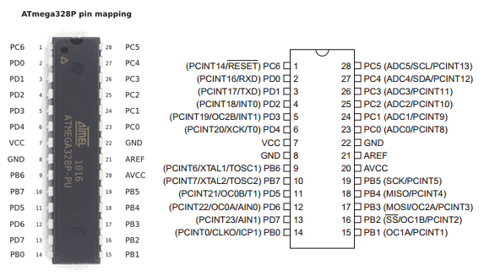

**4.2** **MOTOR DRIVER**

L293D is dual H-bridge motor driver. Motor drivers act as current amplifiers since they take low current control signal and provide a higher current signal. This high current is used to drive the motors.

We designed our motor driver PCB by referring the L293D internal structure.

|  |  |  |
| --- | --- | --- |
| Parameter | **L293d** | **L298n** |
| Circuit | Quadruple half bridge | **Dual full H bridge** |
| Supply voltage range | 4.5-36v | **Up to 46 v** |
| Output current | 600 mA | **2 A** |
| Noise immunity | High | **High** |
| Over-temperature protection | NO | **YES** |
| Internal ESD protection | **YES** | NO |
| Cost | Low | **Comparatively cost** |
| Current Sense | No | **Yes** |

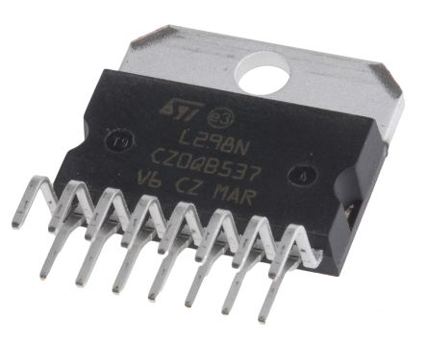

**4.3** **DC MOTOR:**

DC motors for the movement of the robot. DC motors are connected to the wheels of the robot. The speed and load shifting capacity of robot will depend upon the RPM and Torque generated by the motors.

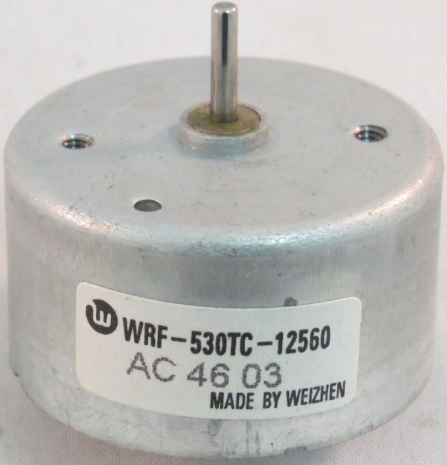

**4.4** **SERVO MOTOR SELECTION:**

|  |  |  |
| --- | --- | --- |
| **Features** | **SG90** | **MG995** |
| Input | PWM | PWM |
| voltage | 4.8v-5v | 4.8v-7.2v |
| Rotation angle | 360 degree | **120 degree** |
| Maximum torque | 1 KG | **8.5 KG** |
| Max lifting weight with 8.5cm shaft | 294 Grams | **1000 Grams** |
| Arm opening time | **12.5 msec** | 150 msec |
| Weight | **14.7 g** | 55 g |
| Dimensions | **32 x 12 x 32 mm** | 40.7 x 19.7 x 42.9 mm |

This high-speed standard servo can rotate approximately d120 degrees (60 in each direction). And we need only 45degree rotation for the robotic arm to completely open and close.

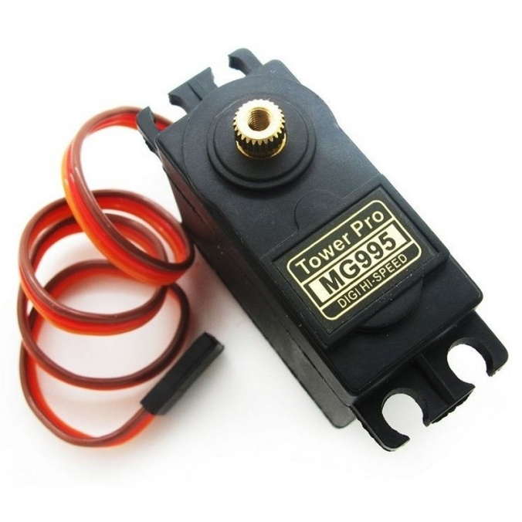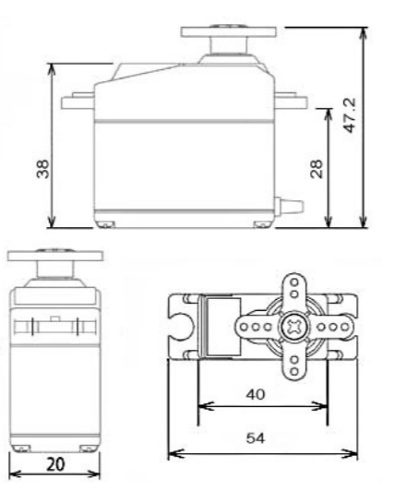

**Specifications**

• Weight: 55 g

• Dimension: 40.7 x 19.7 x 42.9 mm approx.

• Stall torque: 8.5 kgf·cm (4.8 V), 10 kgf·cm (6 V)

• Operating speed: 0.2 s/60º (4.8 V), 0.16 s/60º (6 V)

• Operating voltage: 4.8 V a 7.2 V

• Dead band width: 5 µs

• Stable and shock proof double ball bearing design

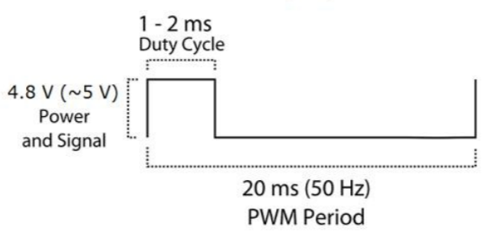• Temperature range: 0 ºC – 55 ºC.

|  |  |
| --- | --- |
| Pulse | Rotation angle |
| 1ms | -90 |
| 1.5ms | 0 |
| 2ms | 90 |

**4.5** **BATTERY SOURCE SELECTION:**

Lithium ion batteries have high energy density and cost less than lithium polymer. Lithium polymer batteries are light weight and have improved safety. However, their cost is high (30% average) as compared to lithium ion.

|  |  |  |
| --- | --- | --- |
| **Features** | **(18650 cells) Li-Ion** | **(Orange) Li-Po** |
| Ageing | Loses actual charging capacity | **Retains charging capacity better than Li-Ion** |
| Energy Density | **High Energy Density** | Low as compared to Li-Ion |
| Conversion Rate | **The capacity to convert battery into actual power 85-95%** | 75-85% |
| Safety | More Volatile as compared to Li-Poly | **More Safety, Less chance of explosion** |
| Cost | **Cheaper (200)** | Slightly Expensive (+30%) |
| Weight | Heavier | **Light Weight** |
| Charge Duration | Longer Charge | **Comparatively Shorter** |

We are using lithium-ion battery to power the robot. As Lithium-ion batteries are rechargeable batteries and portable, with a high energy density.

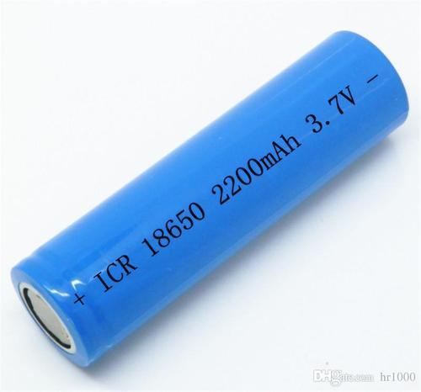

One cell will provide nearly 6Amperes of current. We are using 3 cells.

**4.6** **BLUETOOTH MODULE (BM-10)**

A communication interface is necessary for the robot to convey location information.

|  |  |  |
| --- | --- | --- |
| **PARAMETERS** | **HC-05** | **HC10** |
| Bluetooth version | BLE 2.0/3.0 | **BLE4.0** |
| Power consumption | Low | **Very Low** |
| cost | **Rs 283 /-** | Rs 342 /- |

We are using Bluetooth module BM-10 (having Bluetooth 4.1 technology).

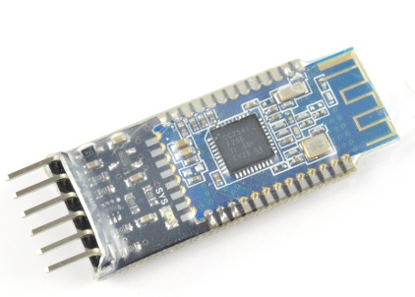

**4.7** **ROBOT ARM**

A robotic arm is a type of mechanical arm. Which can perform near similar to human arm. Our robotic arm is specially designed by us for pick and place type task. It is designed by online 3D design software (TinkerCad). And made using 3D printing technology.

* **3D DESIGN:**

We tried various shapes and sizes to obtain maximum grip as well as high strength. Previously we finalized ‘F’ shaped arms with 4 teeth on each arm. But it would fail to hold round shaped objects.

So, we provided angles to arm & increased number of teeth so that it would hold the multiple sides of object and get maximum grip.

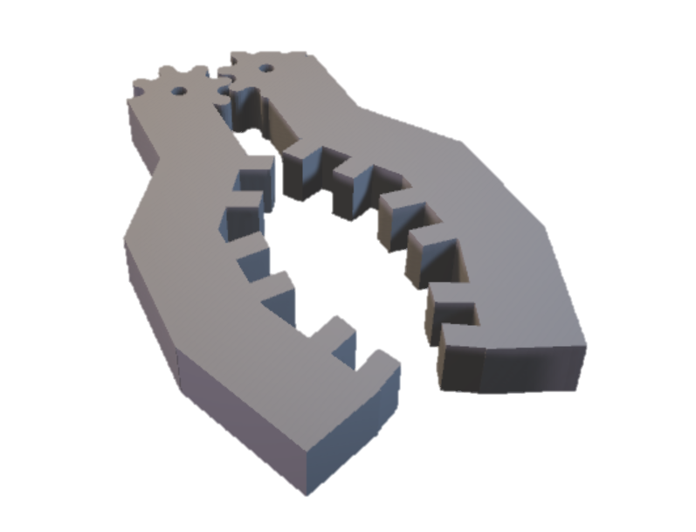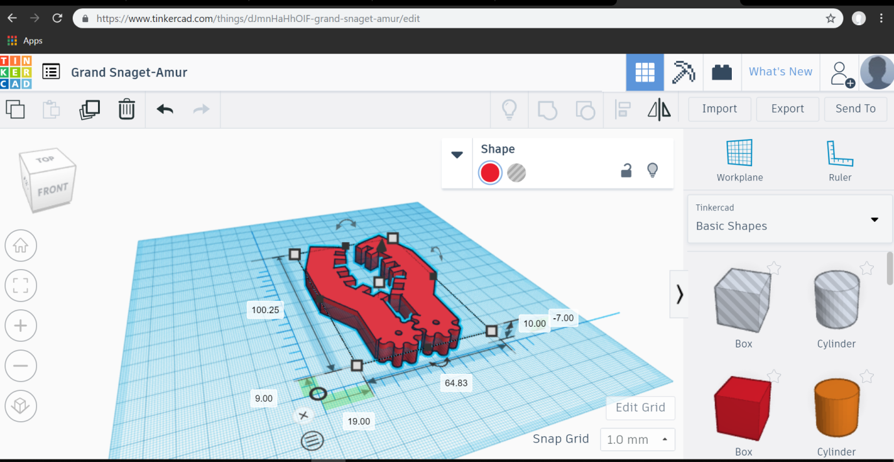 Gears are also added so that whole arrangement can be moved using single actuating element (servo motor).

This 3D structure is designed using an online software ‘TinkerCad’.

* **3D PRINTING:**

To fabricate this 3D object, we used 3D printing technology. A special machine called 3D printer can make this 3D structure. We have to provide only 3D object file (.stl file) & select the amount of material to be filled.

3D printer is an expensive machine that wasn’t available with us. So, we took help of a company ‘Infinity Systems’ to fabricate that structure.

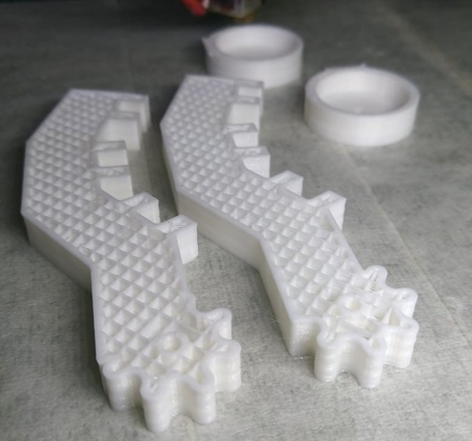

* **MATERIAL USED:**

Three type of materials can be used to print this object:

* + HIPS (high impact polystyrene)
  + ABS (Acrylonitrile Butadiene Styrene.)
  + PLA (polylactic acid).

HIPS is costly material with not so considerable features.

[ABS](http://amzn.to/2mdb53v)  is [widely available](http://amzn.to/2mdb53v) and has been a very popular plastic in the development of prosumer 3D printing from the start. It melts consistently at around 225 degrees Celsius, which can easily be achieved with small and home-safe electronics.

[PLA](http://amzn.to/2lXFQJg) is made from corn starch or sugar cane and is biodegradable, so it’s more environmentally-friendly than ABS. It melts can melt at a lower temperature between 190 and 210 degrees and doesn’t smell bad when it does.

PLA also has high tensile strength(37Mpa) than ABS (27Mpa).

So, by looking at these advantages we chosen PLA for our application. Because of high strength Only 25% fill of PLA can satisfy the application need.

**4.8** **CHASSIS DESIGN:**

Chassis is internal vehicle frame that provides base and supports an artificial object in its construction and use, it also provides protection for some internal parts.

Metal plates, fibre, or MDF can be used to make Chassis.

Metal plates are hard to work with. Cutting, drilling, and welding requires special tools & too much efforts. But MDF can be cut using normal hack-saw blade, and drilling can also be done easily.

|  |  |  |  |
| --- | --- | --- | --- |
| **Features** | **Aluminium Sheet** | **MDF** | **Plywood** |
| Cost | High | **Low** | Moderate |
| Cutting and drilling | Not easy | **Can be cut with hand easily** | Not easy |
| Weight | High | **Low** | Moderate |
| Water resistance | **No dominant effect of water** | It soaks water and swells | It also soaks water slowly |
| Safety | Hazardous due to sharp edges | **Safe** | **Safe** |

So, we used MDF material (Medium Density Fibreboard) to make the chassis.

Medium-density fibreboard (MDF) is a wood product made by breaking down hardwood or softwood residuals into wood fibres, often in a defibrator, combining it with wax and a resin binder, and forming panels by applying high temperature and pressure. MDF is generally denser than plywood.

We chose this material because of advantages like light weight and ease of use

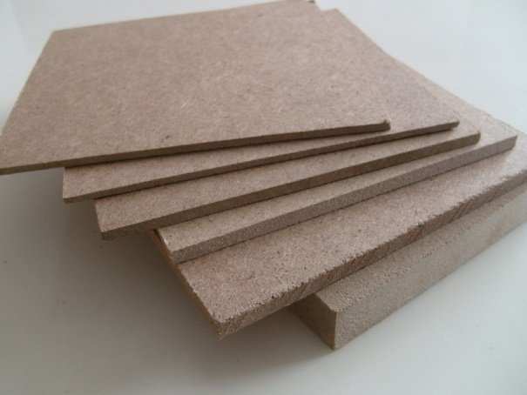

MDF is typically made up of 82% Woodfibre, 9% urea-formaldehyde resin glue, 8% water and 1% paraffin-wax.

1. **SOFTWARE ASPECTS:**
   1. **KICAD: -**

* This software is used for PCB Designing
* We have designed a controller board for ATMEGA 328P-PU and Motor driver using L298N using KICAD.
* First, we made a schematic for these boards and then updated PCBs from schematic by assigning them appropriate footprints.
  1. **ARDUINO IDE: -**
* Arduino IDE is used for microcontroller programming
* Program consists of programming for Motors, Sensors and Motor driver, Servo Motor.
  1. **PROTEUS: -**
* This software is used for simulation purpose
* We have performed simulation of this Smart Wireless controlled Pick-N- Place Line Following Robot circuitry in order to check whether it is working or not.
  1. **TIKERCAD: -**
* TinkerCad is a free, easy-to-use app for 3D design, electronics, and coding. It's used by teachers, kids, hobbyists, and designers to imagine, design, and make anything!
* After Designing 3D Model, the STL File is exported and processed with Slicing Software.

1. **CIRCUIT DESIGN:**
   1. 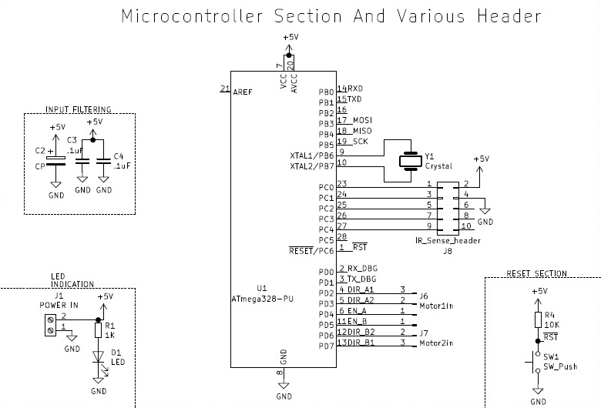**MICROCONTROLLER BOARD:**

* 10KOhm resistor on reset pin to avoid accidental resetting of microcontroller
* Switch SW1 for Resetting Circuitry.
* C1, C4, C5 capacitors for filtering supply noise, gives high frequency noise signals low impedance path to ground (0.1 uF is the most common capacitor value). As Xc=1/(2πfC), more is Frequency lesser is Reluctance.
* ISP header for using external programmer using SPI protocol
* 16 MHz crystal for clock
* LED and 1K Resistor to Indicate Power.
  1. **MOTOR DRIVER (L298N):**

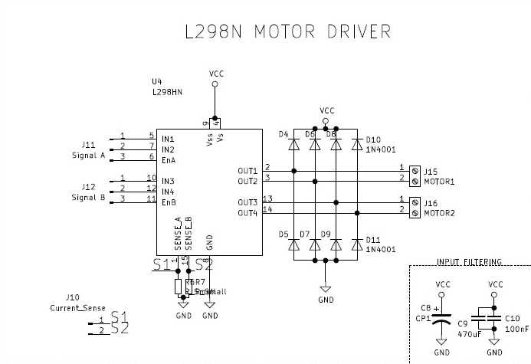

* Max Power 25W.
* Instantaneous Peak Current 3A.
* R6, R7=0Ω(ohm), as we are not using Current Sense.
* Logic Supply of 7V Max.
* 100nF Non-Inductive Capacitor And must be placed as near as possible to GND.
  1. 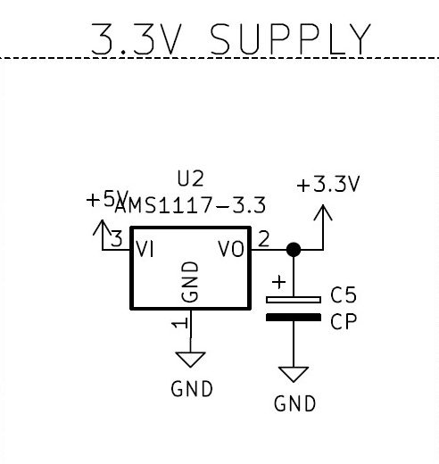**3.3V_REGULATION(AMS1117)**
* Cp = 22uF to ensure stable voltage in all operating conditions.
  1. **5V_REGULATION (IC7805):**

Provides 5V for Arduino Board and Servo Motor.

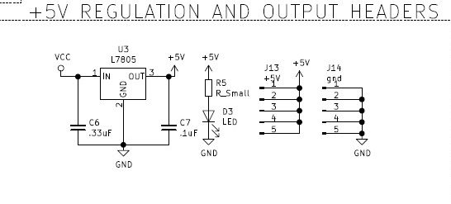

* C6 = 0.33uF for filtering input supply Noise.
* C7 = 0.1uF for filtering Output Supply, to ensued stability in all operating Conditions.
  1. **MOTOR CALCULATIONS:**

Mass of robot = 1.5 KG

Radius of wheel = 5.5 cm = 0.055 m

**Torque required = m*g*R Where -**

**m= mass of robot**

**G= gravity**

**R=radius of wheel**

Therefore

Torque = 1.5*9.8*0.055

=**0.8085 N.M**

* 1. **SERVO CALCULATIONS:**

The servo motor is coupled to one of the arm of robotic arm, & to open the arm fully we need only 45 degree rotation .So

Duty cycle= 1.5+(angle of rotation in degrees /180)

=1.5+(45 /180)

=1.75 ms

* **Weight calculation**:

Torque given **is 8.5 kg-cm for 4.8v supply**

Means it can lift upto 8.5 kg with 1 cm of shaft length

Our arm length is 8.5 cm. So,

**Maximum lifting weight = torque/arm length**

=8.5/8.5

=1 kg

* Maximum arm opening is 11.3 cm ,so maximum holding length is 11.3cm .

It is supposed to hold objects of 2cm to 10 cm more precisely.

* **Arm opening time:**

Speed given is 0.2 sec/60deg

Therefore for 45 degree rotation it will take

( 0.2) 45/60= 0.15

It means arm will open or close in 150 msec (for full speed).

1. **SIMULATION RESULTS:**

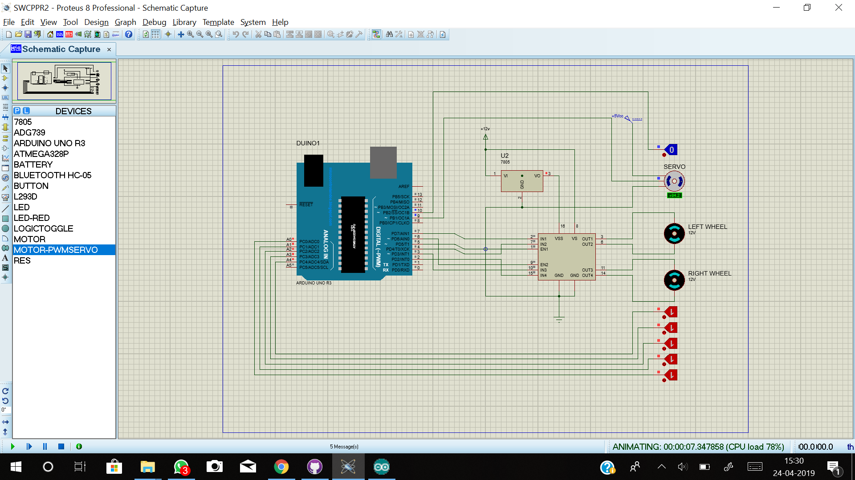

* In place of IR Sensor, Switches are used to simulate the conditions outcomes on Black over Right Line stripes.
* The Motor speed and directions vary according to the conditions written in the code.
* The servo motor is operated when the object is detected.

**8. PCB LAYOUTS:**

**8.1** **MICROCONTROLLER BOARD:**

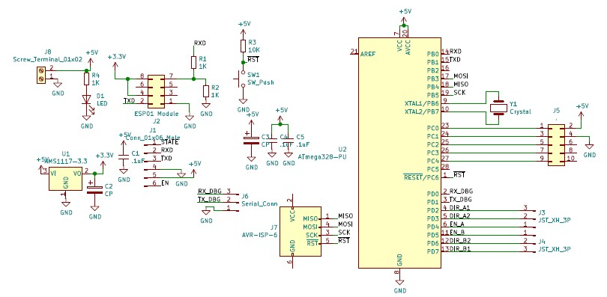

**SCHEMATIC DIAGRAM**

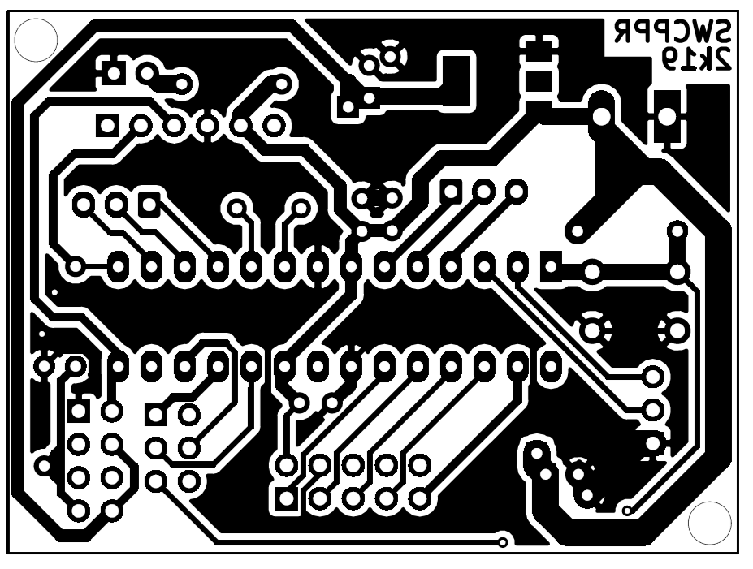

**PCB LAYOUT (BOTTON LAYER)**

**8.2** **MOTOR DRIVER BOARD:**

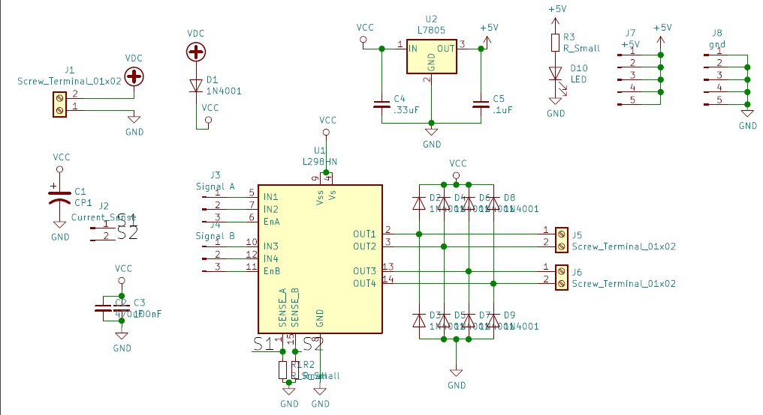

**SCHEMATIC DIAGRAM**

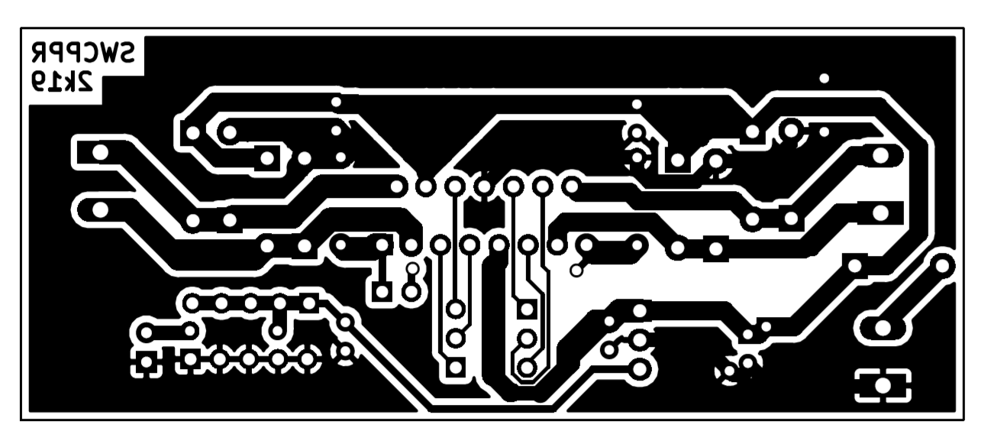

**PCB LAYOUT (BOTTON LAYER)**

1. **TESTING OF MODULES:**
   1. **MOTOR DRIVER L298N:**

Testing is done to ensure proper functionality of the circuits. Individual circuits & modules should be tested separately so that there will not be any problems in further design.

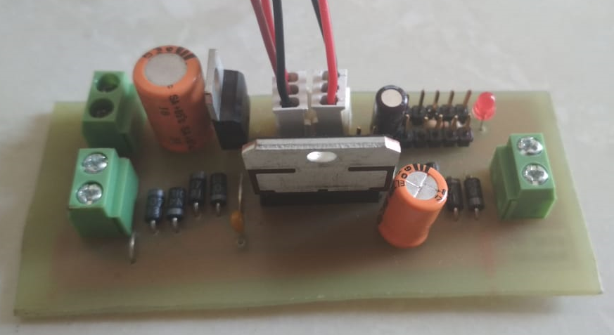

(**top)**

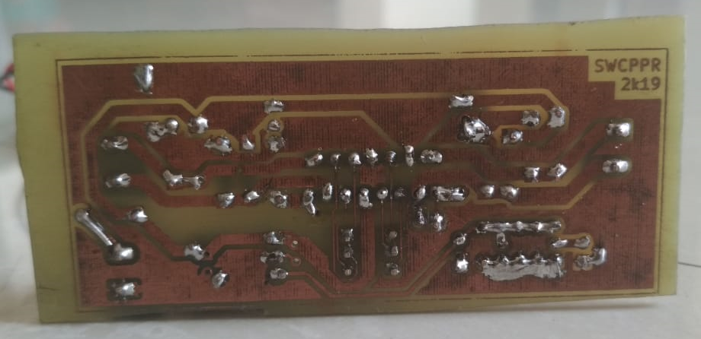

(**BOTTOM**)

**L298 Board after soldering (2 channel)**

We tested the board in 3 steps

* Component test

We checked that, all the components are in place & soldered properly or not.

* Continuity test
* By using DMM we checked the continuity of tracks to ensure the proper conduction of the circuit.
* Some points that are supposed to be isolated but get connected by mistake are also found out by continuity test.
* Functionality test
* In this step we check the actual operation of the circuit.
* This includes applying input and checking weather circuit is giving proper output or not.
* We gave control signals using 5v & GND headers on the board and checked the output voltage using DMM.
* Output voltage should be positive for clockwise and negative for counter-clockwise direction.
* We performed this test for both the channels & got proper output.

**9.2 MICROCONTROLLER BOARD:**

We tested the board in 3 steps

* Component test

We checked that, all the components are in place & soldered properly or not.

* Continuity test
* By using DMM we checked the continuity of tracks to ensure the proper conduction of the circuit.
* Some points that are supposed to be isolated but get connected by mistake are also found out by continuity test.
* Functionality test
* In this step we check the actual operation of the circuit.
* 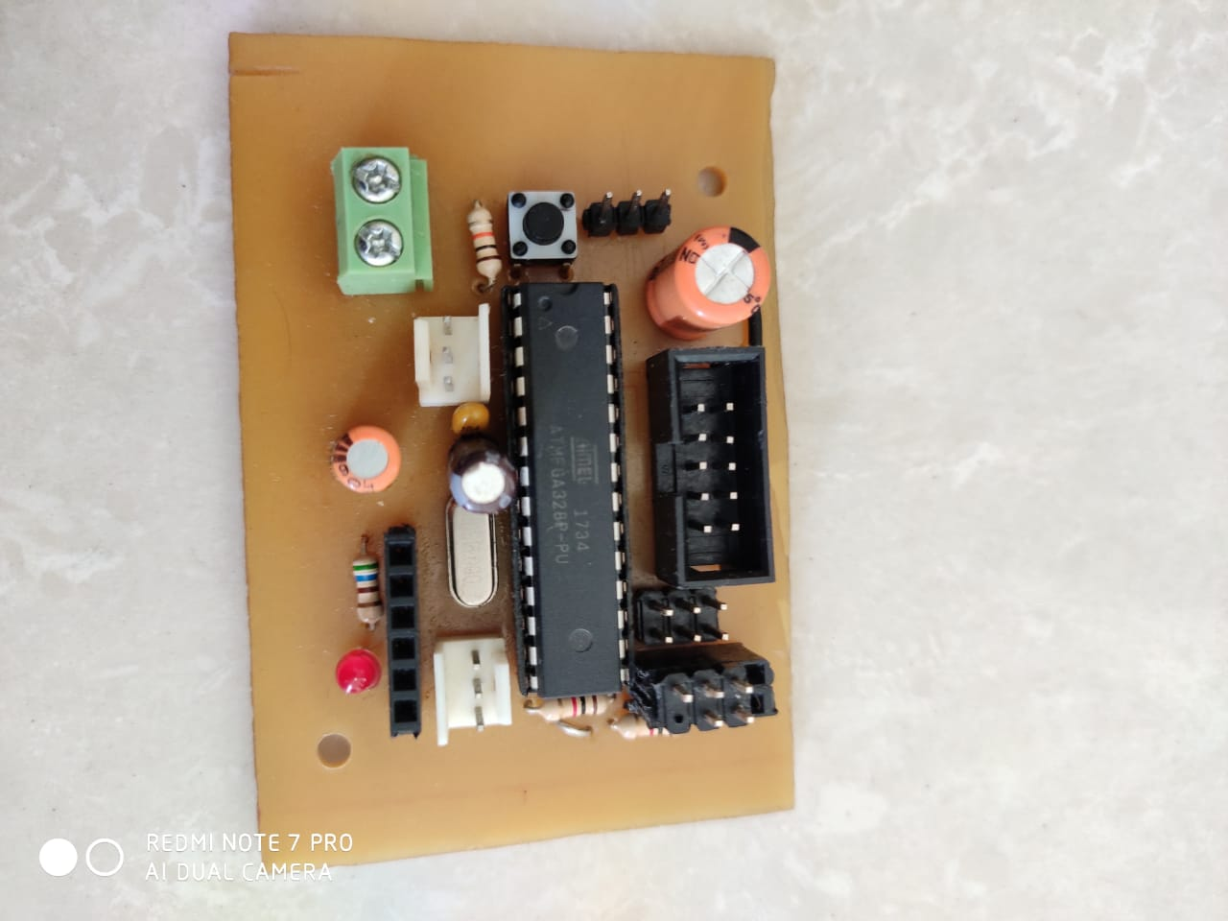This includes applying input and checking weather circuit is giving proper output or not.

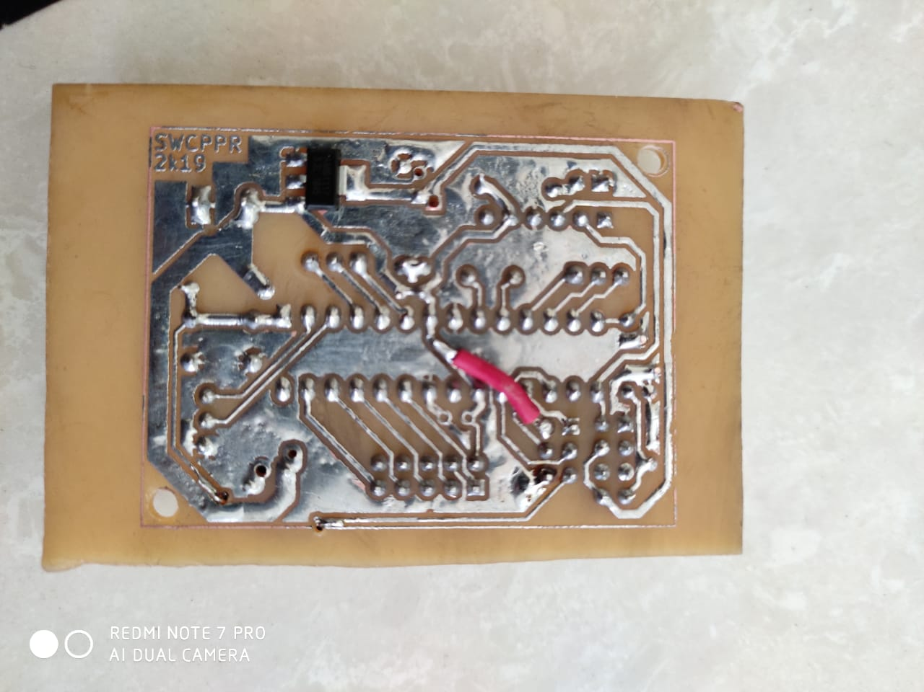

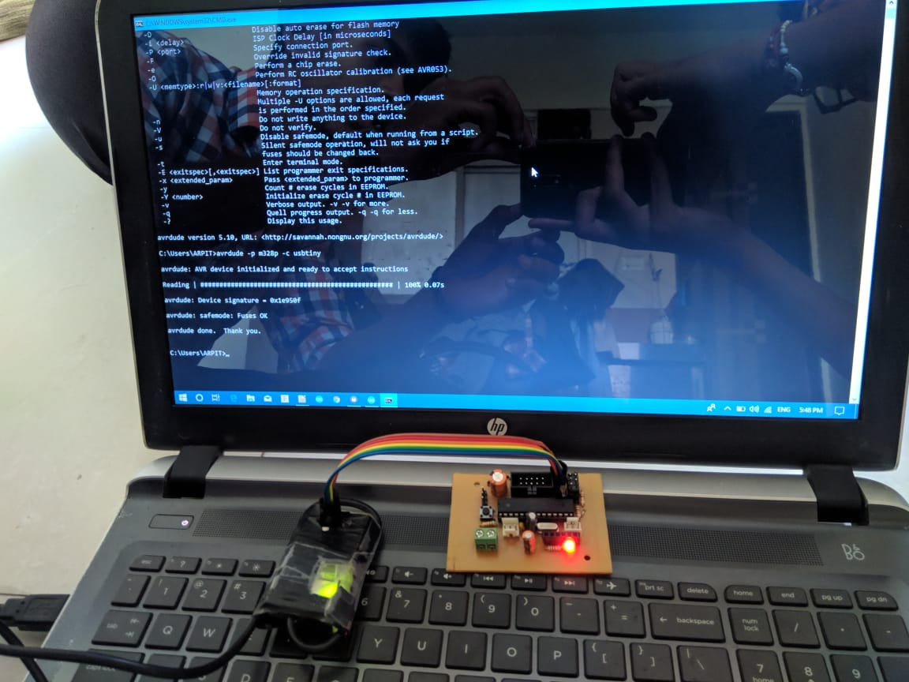

-Testing Working of Board using **“avrdude”**

**9.3 HC-09 BLUETOOTH MODULE:**

We tested the board in following steps:

* For testing purpose, we interfaced Bluetooth module to the Arduino UNO board. And wrote a program to display the received data on computer screen
* We selected alphabets A to G as valid data and all other characters, signs, spaces & special characters as invalid data.
* We have pin0 and pin1 of UNO board as RX and TX respectively, that we are using for sending the received data on computer.
* So, we used pins 8 and 9 to interface Bluetooth module. A function called SoftwareSerial
* Configures the normal GPIO pins as TX and RX for serial communication.
* Data transmitted through Mobile phone via app Serial Bluetooth terminal
* Arduino has inbuild LED connected on pin 13. We used that LED to indicate that valid data is received.
* 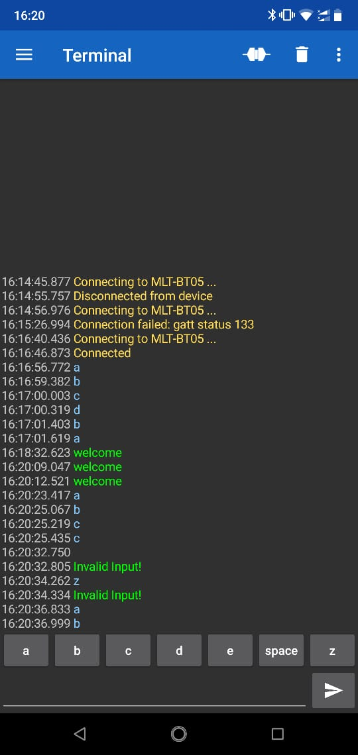Connection chart

|  |  |
| --- | --- |
| HC-09 | Arduino UNO |
| State | Nc |
| RXD | D9 |
| TXD | D8 |
| GND | Gnd |

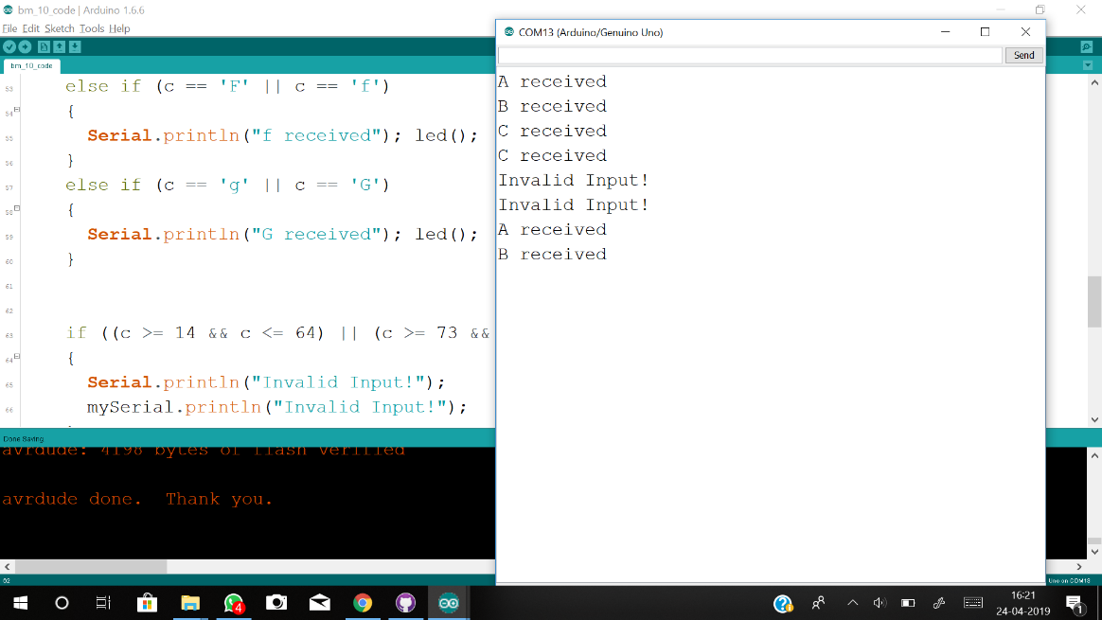

-Snap of **Mobile App** and **Serial Terminal**

**9.4 SERVO MOTOR:**

As discussed before, Testing is done to ensure proper functionality of the circuits. Individual circuits & modules should be tested separately so that there will not be any problems in further design.

For Servo motor we performed only functionality test because it is a ready-made device & its internal circuits are not easily accessible.

Testing Servo motor requires PWM signal for its operation. Duty cycle of this input signal decides the angle of rotation of the shaft.

For testing purpose, we interfaced the motor with Arduino UNO (PIN 3).

And wrote a program to rotate the motor in both directions.

Connections: -

|  |  |
| --- | --- |
| Servo pins | Arduino Uno pins |
| PWM | PIN 3 |
| VCC | +5V |
| GND | GND |

**Program**

#include <Servo.h> // Include Servo library

int servoPin = 3; // Declare the Servo pin

Servo Servo1; // Create a servo object

void setup()

{

Servo1.attach(servoPin); // define pin 3 for servo1

}

void loop()

{

Servo1.write(0); // go to 0 degrees

delay(1000);

Servo1.write(90); // go to 90 degrees

delay(1000);

Servo1.write(180); // go to 180 degrees

delay(1000);

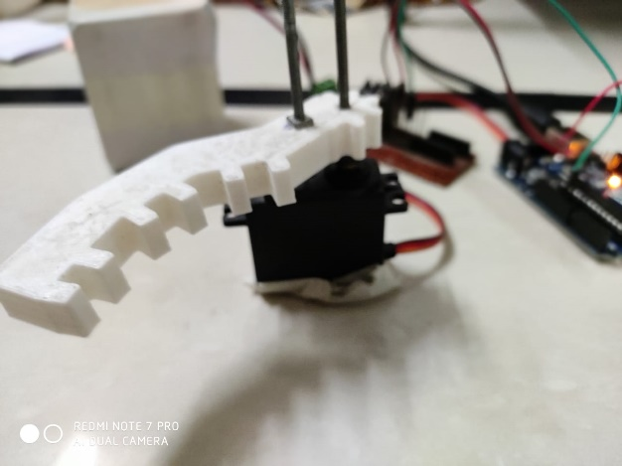}

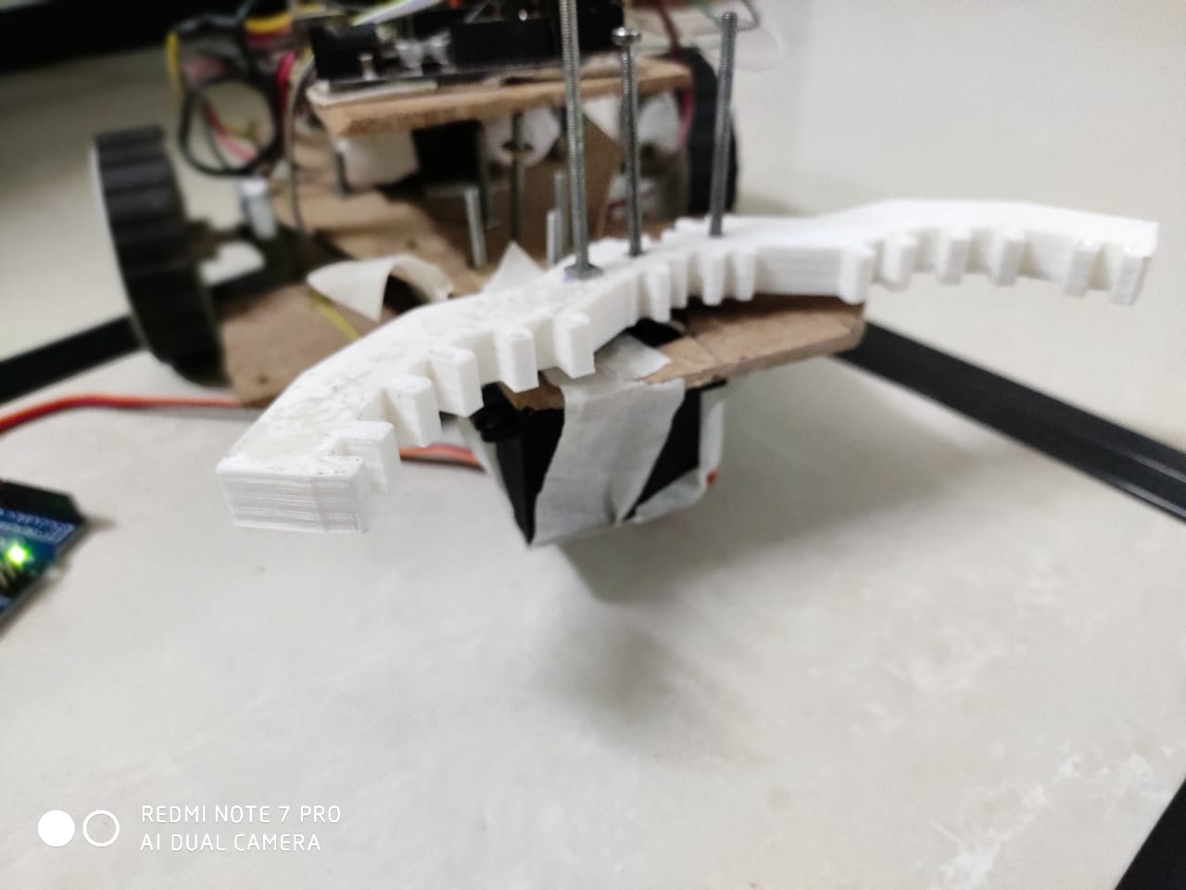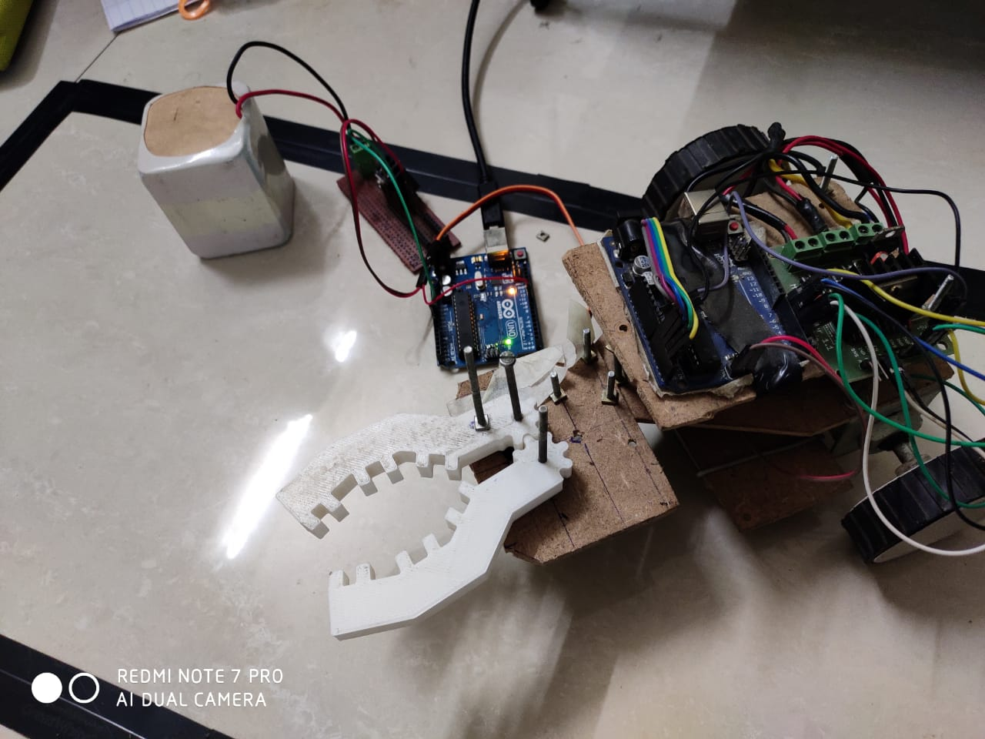

**9.5 INFRARED MODULE:**

* We used IR sensor array for line sensing. It is array of five IR sensors with 5 digital outputs.
* It gives 0 & 1 signals for black and white colour respectively.
* We performed functionality test for this module.
* By interfacing the IR array to Arduino Uno board, we transmitted the signal on serial terminal of pc.
* And checked the outputs by moving the sensor array on black and white backgrounds.

Connections

|  |  |
| --- | --- |
| IR module | Arduino Uno |
| Sensor1 | 8 |
| Sensor2 | 9 |
| Sensor3 | 10 |
| Sensor4 | 11 |
| Sensor5 | 12 |
| VCC | +5V |
| GND | GND |

Test program

const int mod1 = 8;

const int mod2 = 9;

const int mod3 = 10;

const int mod4 = 11;

const int mod5 = 12;

unsigned long int val = 0b00000000;

//variable to store Sensor data

void serialprint()

{

Serial.println(PINB, BIN);

Serial.println("_______________________");

}

void setup()

{

Serial.begin(9600); //set baudrate 9600

DDRB = 0x00; // make port B as output

delay(1000);

}

void loop()

{

serialprint(); //send sensor values on serial terminal

uint8_t val = PINB; //copy the sensor values in a variable

}

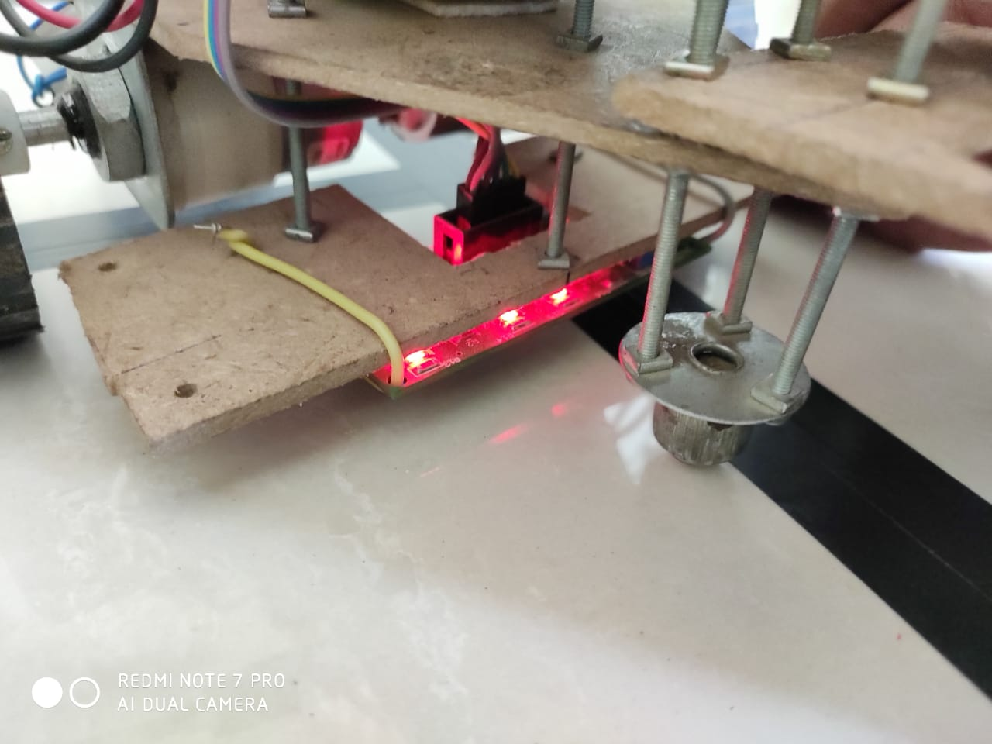

-IR Sensor testing with Black line on White Background.

1. **CABINET DESIGN AND ASSEMBLY:**

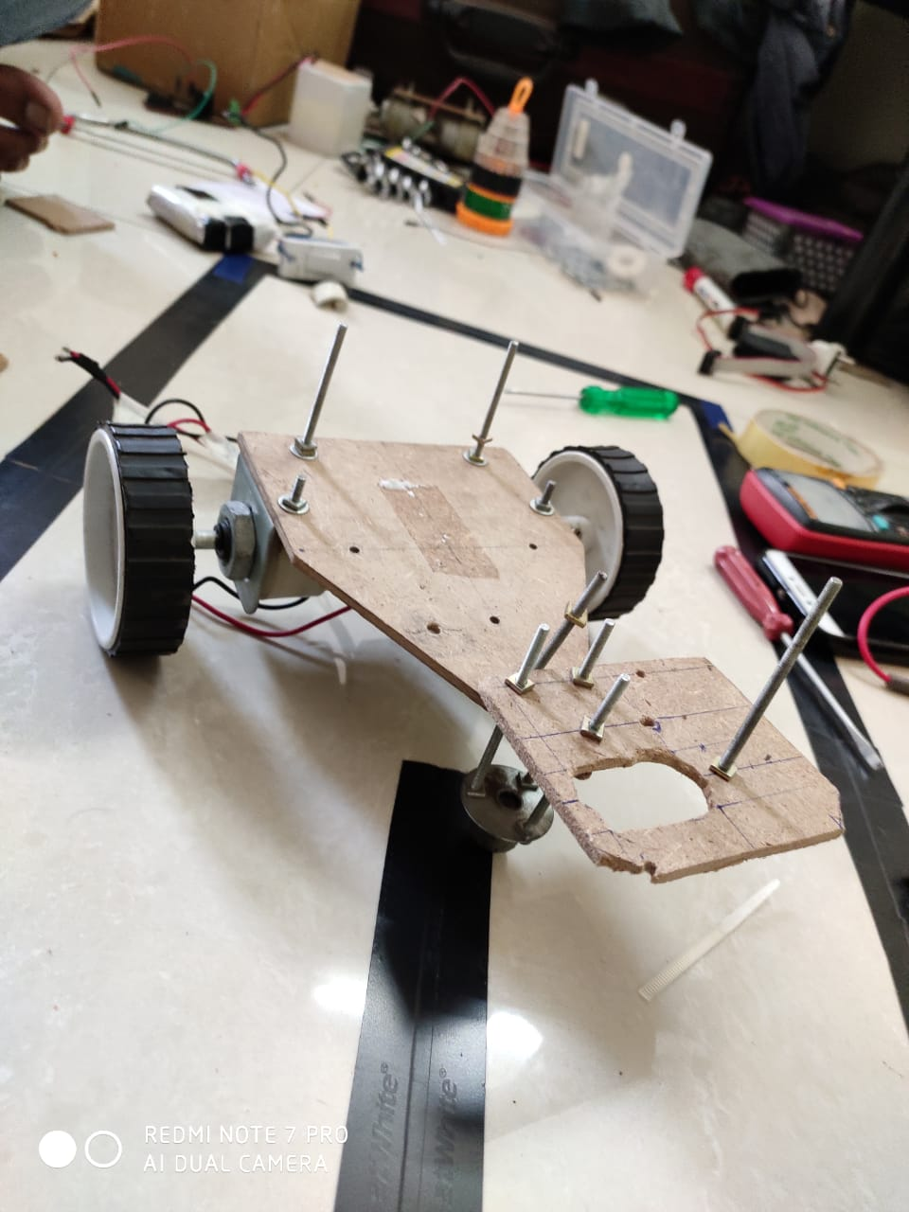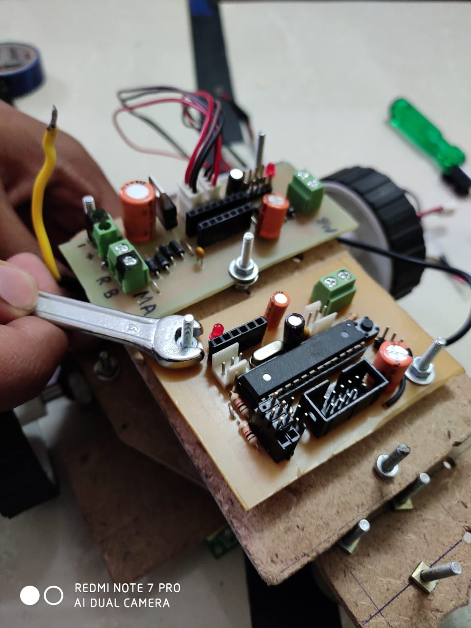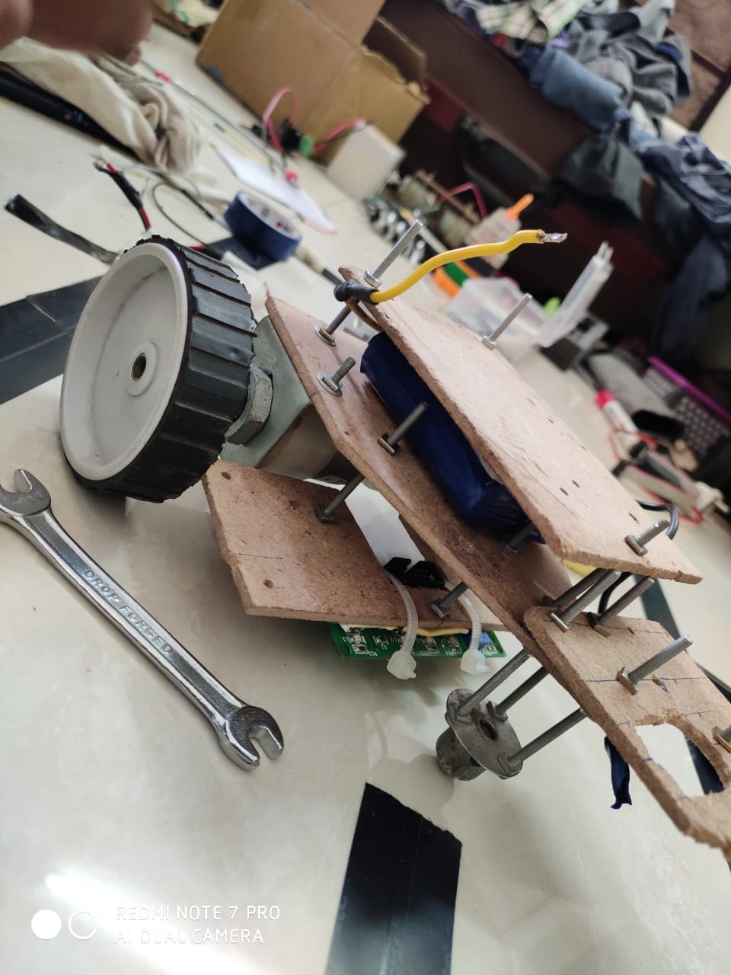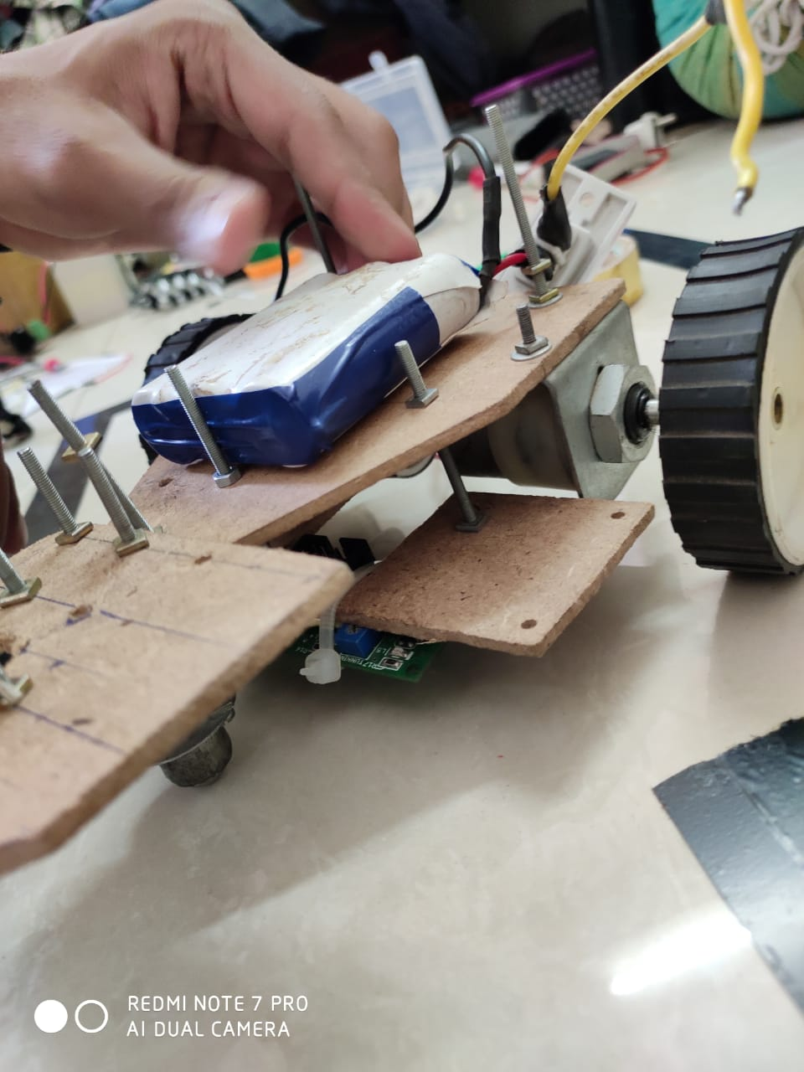

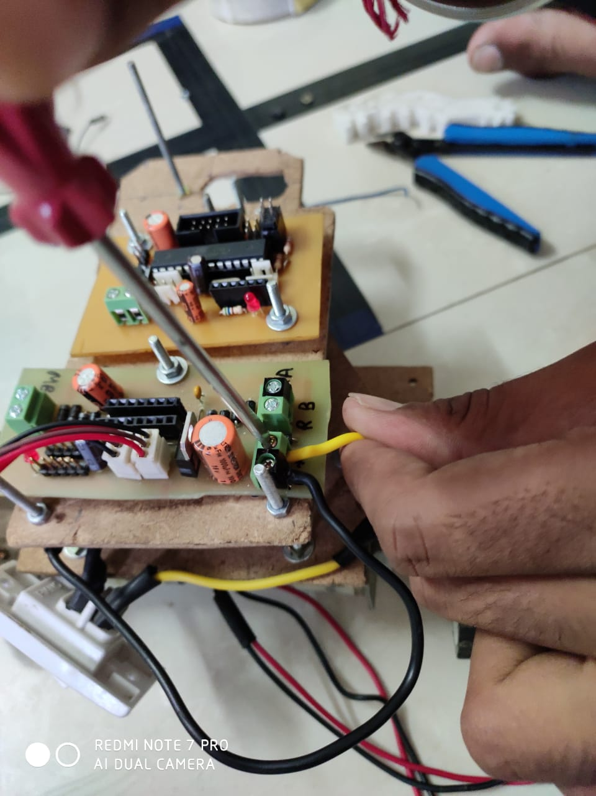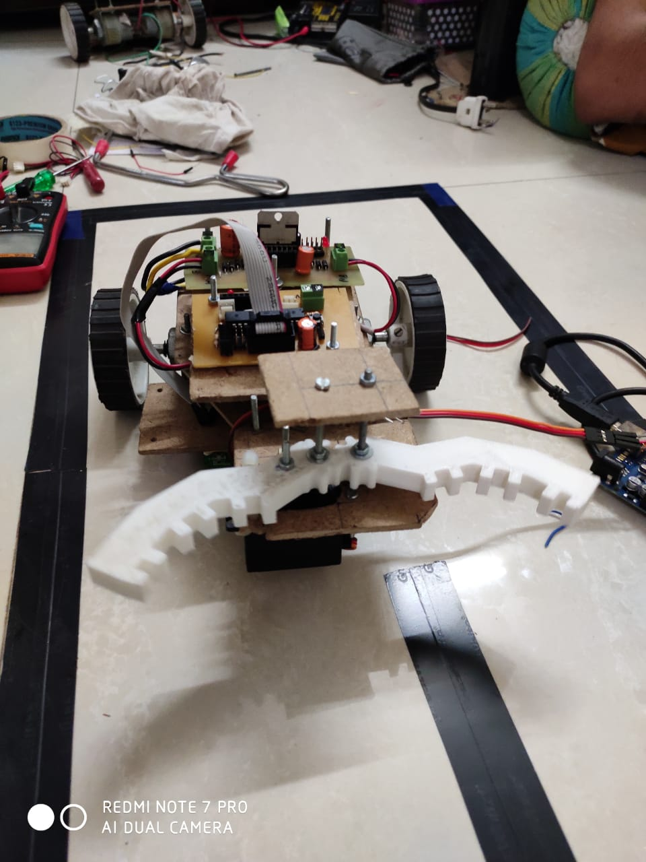

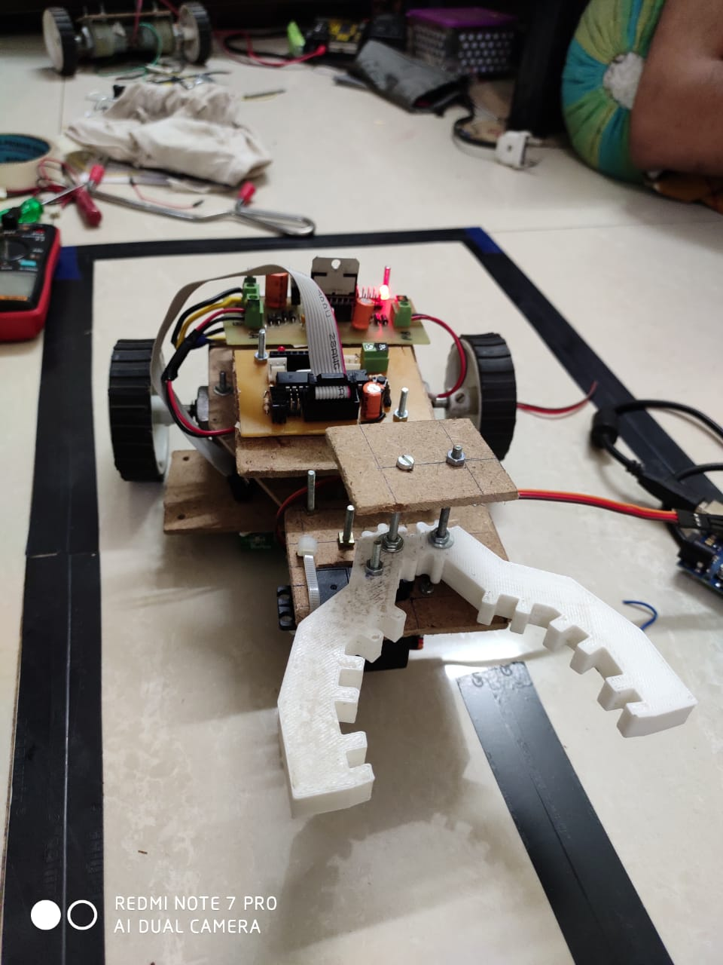

1. **BILL OF MATERIALS:**

|  |  |  |  |  |
| --- | --- | --- | --- | --- |
| **Sr. No** | **Component Name** | **Value** | **Quantity** | **Amount** |
| 1 | PCB Manufacturing (Acetone, Copper clad, FeCl3, Safety Gloves,) |  | 2 | 200₹ |
| 2 | ATmega328-PU | 28pin DIP | 1 | 125₹ |
| 3 | AMS1117-3.3 | SOT-23 | 1 | 5₹ |
| 4 | L298HN | TO-220(15) | 1 | 110₹ |
| 5 | L7805 | TO-220(3) | 1 | 10₹ |
| 6 | Crystal HC18-U | 16MHz | 1 | 4₹ |
| 7 | Resistor THT | 10K, 1K | 4 | 1₹ |
| 8 | Capacitor Disc THT | 1uF | 4 | 2₹ |
| 9 | LED | 3.5mm | 2 | 6₹ |
| 10 | JST Connection Header | 3pin male | 3 | 16₹ |
| 11 | Motor | (wrf-530Tc-12560) | 1 | 300₹ |
| 12 | Diode 1N4001 | THT | 9 | 9₹ |
| 13 | Button Switch | 4pin | 1 | 10₹/piece |
| 14 | Capacitor Disc THT | 100nF, 470uF,.33uF | 1 | 9₹ |
| 15 | Connection Header Male | 2.54pitch | 1 | 6₹ |
| 16 | Connection Header Female | 2.54pitch | 1 | 6₹ |
| 17 | Wheels | 6cm | 2 | 120₹ |
| 18 | Servo Motor | MG995 | 1 | 350₹ |
| 20 | Chassis (MDF, Motor hinges, Screws, nuts washers,) |  |  | 200₹ |
| **1489**₹ |
|  |

**Approximate Budget is 1500**₹.

1. **REFERENCES:**

**-ARDUINO DESIGN**:<https://www.allaboutcircuits.com/technic-alarticles/understanding-arduino-uno-hardware-design/>

**-SG90**: <http://www.ee.ic.ac.uk/pcheung/teaching/DE1_EE/stores/sg90_datasheet.pdf>

**-MG995**: <https://www.towerpro.com.tw/product/mg995/>

**-BLUETOOTH MODULE:** <https://howtomechatronics.com/tutorials/arduino/arduino-and-hc-05-bluetooth-module-tutorial/>

**-MDF:** <https://en.wikipedia.org/wiki/Medium-density_fibreboard>

-**3D Design:** <https://www.tinkercad.com/things/dJmnHaHhOIF-grand-snaget-amur/edit>

-**Materials**: [https://www.3dhubs.com/knowledge-base/pla-vs-abs-whats-difference](https://www.3dhubs.com/knowledge-base/pla-vs-abs-whats-difference%20)

-**MDF Plywood :** <https://www.livspace.com/magazine/mdf-vs-plywood-comparison/>

1. **PROJECT PHOTO:**

* 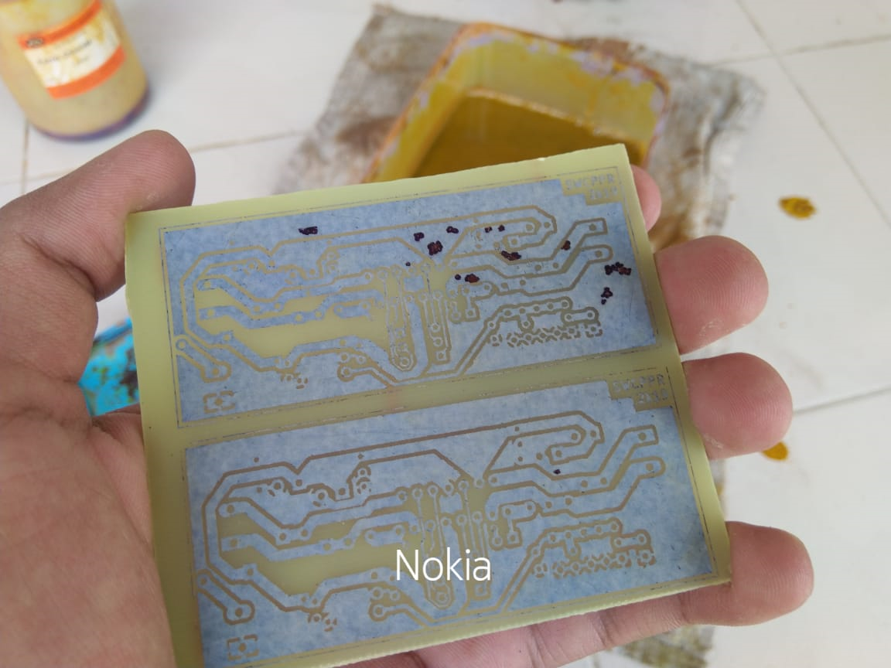**Hardware:**

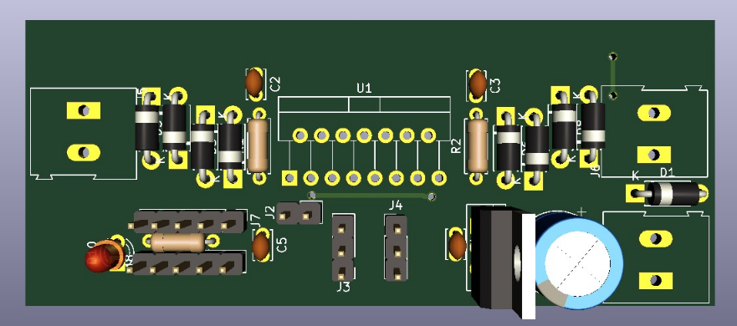

-3d model of Mosfet Driver as Designed on KiCad

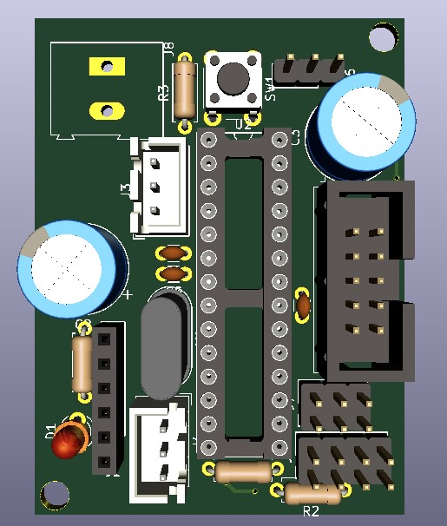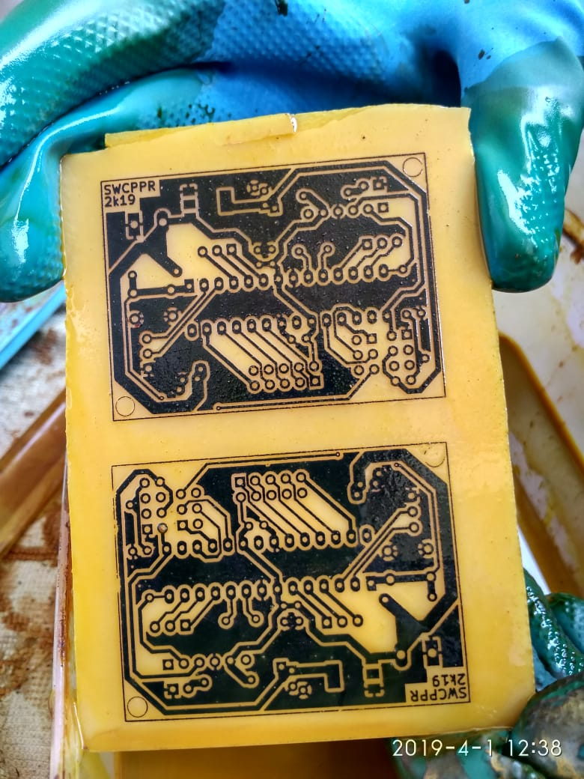

-3d model of Microcontroller Board as Designed on KiCad

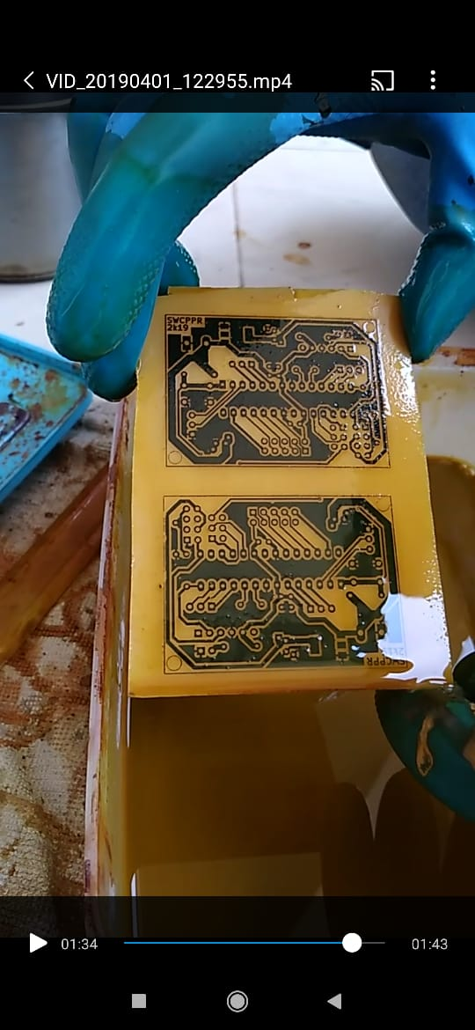

-Etching of Boards

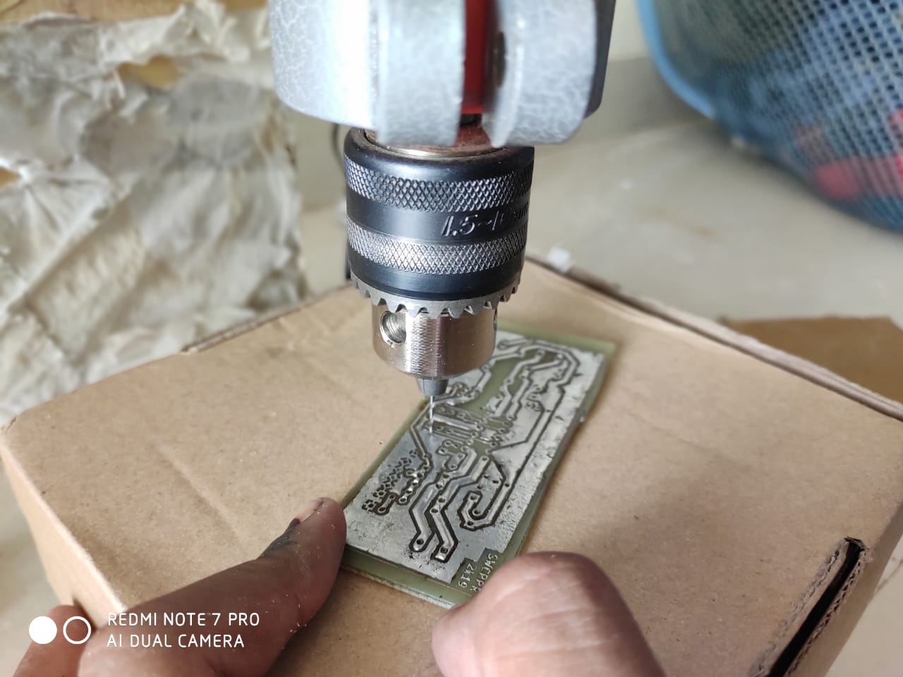

-Drilling of Boards

-Soldering of Boards

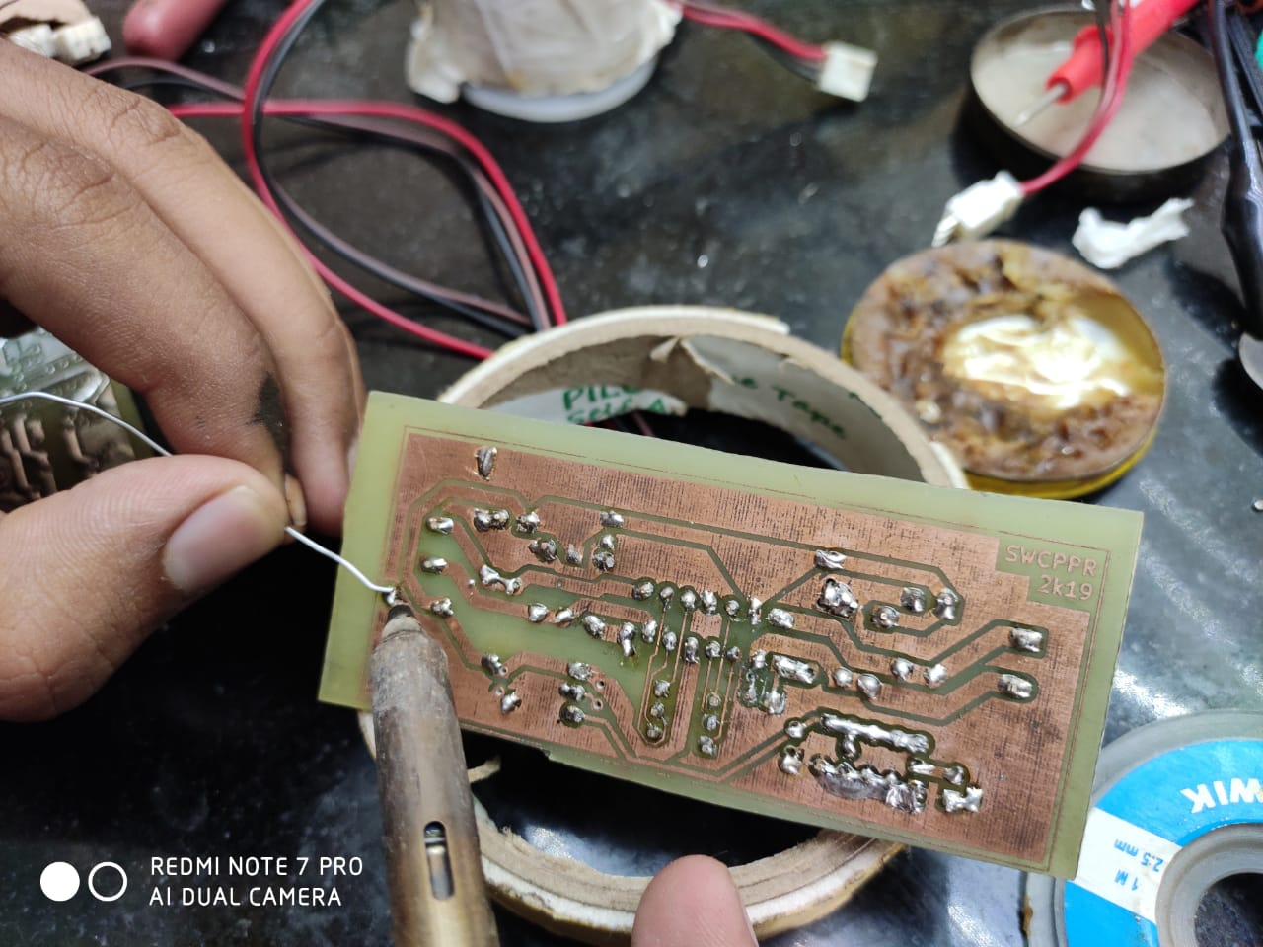

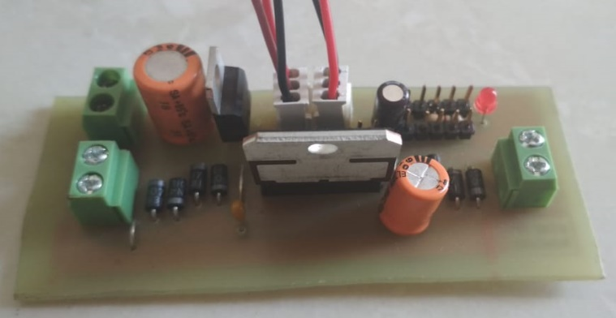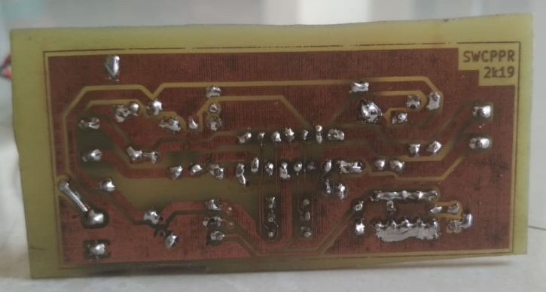

-MOSFET Driver after Soldering (Top side on left)





-Microcontroller Board after Soldering (Top side on left)

1. **CONCLUSION:**

The design and development of pick and place robot has been carried out. A prototype was confirmed functional working of robot system. This system would make it easier for human beings to pick and place the risk of handling suspicious objects, which could be hazardous in its present environment and workplace. Complex and complicated duties can be achieved faster and more accurately with this design.

A robotic arm is implemented using Atmega328P-PU in pick and place objects more safely without incurring much damage. The robotic arm used here contains a soft catching gripper, which safely handles the object. In the modern era, time and man power are major constraints for the completion of a task.

By the use of product, the industrial activities and hazardous operations can be done easily and safely in a short span of time. The use of soft catching gripper and low power wireless communication technique like BLE (4.0) makes our system more effective when compared to other systems. The developed system is capable of lifting only small weights; by introducing high torque motor large weights can be picked. A wireless camera can also be implemented to track the movement of the vehicle and thus it can be used for defense purposes. The range is also a limitation here but it can be enhanced.

1. **DATASHEETS:**

-pto